# TechMart QA – Bug Report

*This document reports the functional, UI, and backend issues identified during testing of TechMart, including product cards, cart behavior, search, filters, and checkout.*  
**Submitted by:** Bayan Zughaiar  
**Date:** 24/08/2025

**Total Bugs Found:** 9 (3 High, 4 High Priority, 2 Medium)   
  
**P.S.:** There are additional test cases that could be documented. Given more time and less stress, I would like to add a summary table for quick reference of all bug report with their details more comprehensively.

### Testing Coverage Gaps:

* Mobile responsiveness testing needed
* API endpoint testing required
* Load testing for production readiness

**1. Product Card Action Button Inconsistency**

* **Bug ID:** BUG-PRODCARD-01
* **Title:** Inconsistent action buttons on product cards (“Add to Cart” vs “Select Options”).
* **Severity:** Medium
* **Priority:** Medium
* **Environment:** Products page (/products)
* **Likely Team:** Frontend

**Steps to Reproduce:**

1. Navigate to the **products page**.
2. Observe the **product cards**:
   * iPhone 14 Pro → **Add to Cart**
   * Samsung Galaxy S23 → **Add to Cart**
   * MacBook Pro 16” → **Select Options**
3. Check if similar products with stock available display consistent action buttons.

**Actual Result:**

* Some product cards show **“Add to Cart”**, others show **“Select Options”**.
* No clear reason why the action differs for similar products in stock.

**Expected Result:**

* All products with available stock should have a **consistent action button**.
* “Add to Cart” should appear if product can be directly added.
* “Select Options” should appear only if product requires choosing options (e.g., size, color).

**Notes:**

* Could confuse users and affect the shopping experience.
* Likely a **frontend issue** with how action buttons are rendered for certain products.

Resources:

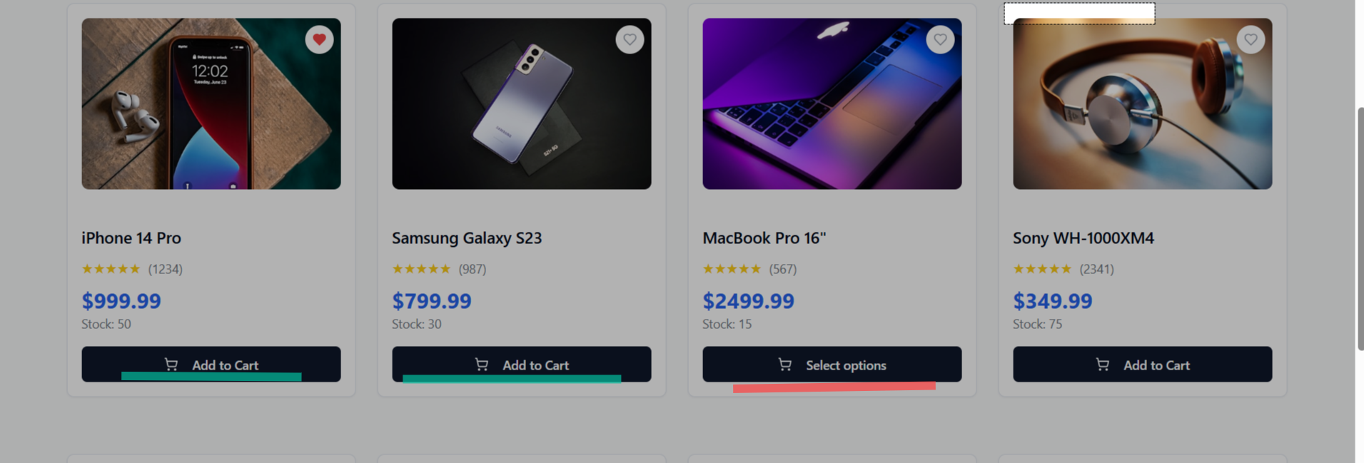

**2 Search Bar Functional Bug**

* **Bug ID:** BUG-SEARCH-01
* **Title:** Search query updates URL but products are not filtered/displayed.
* **Severity:** High
* **Priority:** High
* **Environment:** Products page (/products)
* **Likely Team:** Frontend + Backend

**Steps to Reproduce:**

1. Navigate to the **products page**.
2. Enter a valid product name in the **search bar** (e.g., iPhone 14 Pro).
3. Press **Enter** or click the **search icon**.
4. Observe the **URL update** (e.g., ?search=iPhone%2014%20Pro).
5. Check the product list displayed on the page.

**Actual Result:**

* URL updates correctly with the search query.
* Products on the page **do not filter**; the full list remains displayed.

**Expected Result:**

* Products matching the search keyword should be dynamically displayed.
* If no products match, show a **“No products found”** message.

**Notes:**

* Likely a **frontend filtering/rendering issue** or backend API not returning results.
* Impacts user experience and ability to find products efficiently

**3 Products Page Filters Not Functional**

* **Bug ID:** BUG-FILTER-01
* **Title:** Filters (Currency, Price Range, Results per page, Sort by) do not update the product list.
* **Severity:** High
* **Priority:** High
* **Environment:** Products page (/products)
* **Likely Team:** Frontend + Backend

**Steps to Reproduce:**

1. Navigate to the **products page**.
2. Locate the filters section:

* Currency (USD)
* Price Range ($860 - $1000)
* Results per page (20)
* Sort by (Rating)

1. Change any filter option (e.g., adjust price range, change sort order).
2. Observe the **product list**.

**Actual Result:**

* Selecting or adjusting any filter **does not affect the displayed products**.
* Product list remains the same regardless of selected options.

**Expected Result:**

* Product list should dynamically update according to the selected filter.
* Pagination, sort, and price range should reflect correctly in the displayed products.
* If no products match the filter, display a **“No products found”** message.

**Notes:**

* Likely a **frontend issue** (event handling / rendering) or **backend API not returning filtered results**.
* Severely impacts user experience — users cannot find products efficiently.

**4 Coupon Functionality Bug**

* **Bug ID:** BUG-COUPON-01
* **Title:** “Coupon applied successfully” message appears even for invalid or ineffective coupons.
* **Severity:** High
* **Priority:** High
* **Environment:** Cart page (/cart)
* **Likely Team:** Frontend (UI shows success message) + Backend (totals not updated)

**Steps to Reproduce:**

1. Add one or more products to the cart.
2. Enter any **invalid coupon code** (e.g., INVALID12) in the “Apply Coupon” field.
3. Click **Apply**.
4. Observe the **success message**: “Coupon applied successfully”.
5. Check **Cart Totals**; verify totals remain unchanged.
6. Try **removing or reapplying** any coupon; totals remain unchanged.

**Actual Result:**

* Success message appears regardless of coupon validity.
* Cart totals do not reflect any discount.
* Removing or reapplying coupon does not change totals.

**Expected Result:**

* Invalid coupon should display an **error message** (e.g., “Invalid coupon code”).
* Valid coupon should update **Cart Totals** correctly.
* Removing coupon should revert totals properly.

**Notes:**

* Likely a **frontend issue** for displaying message and a **backend issue** for applying discounts.
* Can mislead users into thinking discount applied.

**5 Cart Grand Total Calculation Bug**

* **Bug ID:** BUG-CART-01
* **Title:** Grand Total incorrectly calculated in Cart Totals.
* **Severity:** High
* **Priority:** High
* **Environment:** Cart page (/cart)
* **Likely Team:** Backend (totals calculation)

**Steps to Reproduce:**

1. Add a product to the cart (e.g., Samsung Galaxy S23 ×1).
2. Navigate to the **cart page** (/cart).
3. Observe **Cart Totals**: Subtotal, Shipping, Grand Total.

**Actual Result:**

* Subtotal: $799.99
* Shipping: $7.99
* Grand Total: $899.99 → **does not match Subtotal + Shipping** ($807.98).

**Expected Result:**

* Grand Total = Subtotal + Shipping – Discount (if applied).
* For this example, Grand Total should be **$807.98**.

**Notes:**

* Bug likely in **backend calculation of totals**.
* Could mislead users at checkout and affect payment amount.

**6 Cart Quantity Limit Bug**

* **Bug ID:** BUG-CART-02
* **Title:** Product quantity in cart capped at 2, cannot add more even if stock allows.
* **Severity:** Medium
* **Priority:** High
* **Environment:** Cart page (/cart)
* **Likely Team:** Frontend (UI controls) + Backend (quantity handling)

**Steps to Reproduce:**

1. Add a product to the cart.
2. Navigate to the **cart page** (/cart).
3. Click the **“+” button** to increase the product quantity.
4. Observe that the quantity **cannot increase beyond 2**.
5. Use the **“-” button** to decrease quantity; it works correctly.

**Actual Result:**

* Product quantity is **capped at 2**.
* Users cannot increase the quantity beyond 2 even if stock allows.

**Expected Result:**

* Users should be able to increase product quantity according to **available stock**.
* Quantity adjustment buttons (“+” and “-”) should function correctly within valid limits.

**Notes:**

* Likely a **frontend restriction** or **backend validation issue**.
* Could affect checkout totals and user experience

**7 Product Detail Page – Quantity Exceeds Stock Display Issue**

* **Bug ID:** BUG-PDP-01
* **Title:** Quantity input allows numbers greater than available stock.
* **Severity:** Medium
* **Priority:** High
* **Environment:** Product detail page (/products/{id})
* **Likely Team:** Frontend

**Steps to Reproduce:**

1. Navigate to a product detail page (e.g., Samsung Galaxy S23: /products/3).
2. Locate the **quantity input field** and **available stock** indicator.
3. Attempt to increase quantity beyond the **available stock number**.

**Actual Result:**

* Quantity can be increased **above the available stock**.
* Stock indicator does not prevent over-selection.

**Expected Result:**

* Quantity input should **not allow selecting more than available stock**.
* System should validate and restrict user input according to stock.

**8 Product Detail Page – Add to Cart Not Working Correctly**

* **Bug ID:** BUG-PDP-02
* **Title:** Adding product from the product detail page does not update cart correctly.
* **Severity:** High
* **Priority:** High
* **Environment:** Product detail page (/products/{id})
* **Likely Team:** Frontend + Backend (Fullstack)

**Steps to Reproduce:**

1. Navigate to a product detail page (e.g., Samsung Galaxy S23: /products/3).
2. Enter a quantity >1 in the **quantity input**.
3. Click **“Add to Cart”**.
4. Check the **cart icon** and cart contents.

**Actual Result:**

* “Add to Cart” shows **success message**.
* Cart **only adds 1 product**, regardless of the quantity entered.
* Cart totals do not reflect the correct quantity.

**Expected Result:**

* Cart should update correctly with the **selected quantity**.
* Cart totals, icon count, and checkout page should reflect actual quantity added.

**9 Checkout Form Does Not Save Entered Information**

* **Bug ID:** BUG-CHKFORM-01
* **Title:** Checkout form does not save entered shipping or payment information; all fields appear optional.
* **Severity:** High
* **Priority:** High
* **Environment:** Checkout page (/checkout)
* **Likely Team:** Frontend + Backend (FullStack)

**Steps to Reproduce:**

1. Navigate to the cart page (/cart) with at least one product added.
2. Click “Proceed to Checkout” to open the checkout form.
3. Fill in Shipping Address fields:

* Full Name: Karim Khalil
* Address
* City
* State
* ZIP Code

1. Fill in Payment Information fields:

* Name on Card: John Doe
* Card Number: 1234 5678 9012 3456
* Expiry Date: MM/YY
* CVV: 123

1. Submit the order by clicking “Place Order.”

**Actual Result:**

* The form does not validate or require any fields.
* Entered information is not saved or processed.
* Order is submitted without the system capturing shipping or payment details.

**Expected Result:**

* Required fields (shipping and payment) should be validated before submission.
* The form should save and process entered information correctly.
* User should receive an error if required fields are empty or invalid.

**Notes:**

* Likely a frontend validation issue and/or backend handling issue.
* This can prevent proper order processing and may cause payment/shipping failures.